RESEARCH PAPER

VIDEO GAME RECOMMENDATION
BY- P. Sri Hari

ABSTRACT
Today, recommendations play a significant role in how businesses operate, assisting in directing clients toward goods they will ultimately wish to purchase. Steam, the most popular PC video game distribution platform, similarly depends on recommendations to increase user involvement. Our team developed a suggest system that can precisely anticipate which games a customer should and will buy next using information obtained from the Steam website. In order to deliver engaging and diverse suggestions and to foster a deeper knowledge of Steam's users and games, our model attempts to mimic recommendation systems frequently found on websites like Netflix, Amazon, and Spotify.

To train a variety of recommender models that target various user purchasing motivations, our data pipeline ingests data comprising user purchase histories and item descriptive summaries. In order to provide predictions in the form of score and ranking, our models primarily leverage cosine similarity with a classification component that makes use of descriptive information. The generated models are then applied to an interface that, given user or game input, generates suggestions that range from a single, all-encompassing list to lists based on genres and even lists that are item-by-item. Additionally, the interface offers statistical analysis of the full data set as well as visuals that explore user and item preference trends.

Keywords - Steam ,Recommendation system , Video game , Cosine Similarity, Statistical Analysis

LIST OF FIGURES

Figure no. | Figure Caption | Page No.
Figure 1 | use of countvectorizer in model | 10
Figure 2 | Before using dropna() in model | 10
Figure 3 | After using dropna () in model | 10
Figure 4 | Feature selection in model | 11

CONTENTS
Front Page
Declaration
Certificate
Certificate by supervisor (HOI/HOD)
Acknowledgement
Abstract
List of Figures
Chapter 1 Introduction
Chapter 2 Review of Litrarture
Chapter 2 Dataset
Chapter 3 Data Preparation
Chapter 4 Data Transformation/ Pre - Processing

Chapter 5 Model Background

Chapter 6 Results &Future scope

Chapter 7 Conclusion
References

Chapter 1
INTRODUCTION

Modern data science and machine learning are built on recommender systems. The effects of recommender systems may be observed everywhere, with applications in social media, business, and government. Recommender systems are models that anticipate a user's rating or preference for a particular item, as the name implies. Unlike conventional machine learning models, recommender systems employ methods from both supervised and unsupervised learning to accomplish their objectives. The words "users" and "items" (in the case of our study, video games) will be used often throughout the rest of the report since recommender systems focus a lot of their modelling on interactions between these two groups of entities.

On Steam, a platform built by Valve Corporation for the distribution of digital video games, is where our initiative is primarily focused. Steam, which was initially designed to allow the integration of its first-party products, has transformed into a comprehensive platform for third-party video games, spanning almost every game made for personal computers (Windows, Mac, Linux). Because it makes it easy for consumers to purchase, download, and keep their games on numerous devices, Steam has surpassed all other video game distribution services for PC users. Once a person has purchased a video game on Steam, they can always access it through their account, similar to how iTunes works for music.The platform tracks player and game data religiously, offering a wealth of tools for analysing user behaviour and video game participation.

Our objective is to create a powerful recommender system based on Steam data that can not only anticipate video games that users will likely buy with accuracy, but also help us better analyse trends in user behaviour and item descriptions.

Chapter 2
REVIEW OF LITRARTURE
A method of filtering data is the recommendation system. They are employed to offer consumers recommendations based on their needs and areas of interest. The recommendation system has been a trending issue since it has become a fairly common approach in recent years and is used by many e-commerce websites and other platforms to recommend news, books, movies, shopping products, novels, music, and much more. Data filtering systems are a subset of recommendation systems. The many kinds of recommendation systems are applied across diverse platforms and are now a crucial component of several applications. It is a method of decision-making that will assist consumers in getting quality content.
Systems for making recommendations are a highly practical and efficient way to filter data. This paper reviews recommendation systems and explains how they function across platforms, as well as the many varieties available, along with their benefits and drawbacks. In this study, we created a game recommendation system using data from Steam, a well-known gaming platform. As one of the largest entertainment industries—possibly even larger than Hollywood—the gaming business will be one that this recommendation system will highlight for players. The amount of money made per individual in the gaming sector might yet increase. There is a lot of room for revenue growth from gamers given that gaming only has 16% of the reach of mobile and other entertainment services. The COVID-19 epidemic severely hurt the entertainment sectors, but it had a major positive impact on the gaming sector, which grew by approximately 30%.

Chapter 2
DATASET

Data from the Steam Platform is used. In order to create a more accurate data for each game, I have exclusively used the Steam_data for the project. Since it has video games categorised on many different grounds, the data I used from GitHub (https://github.com/psHARI/game-recommendation-/blob/main/steam games.rar) is ideal for my project.

Steam_games dataset is categorized in following -

- URL
- Types
- Name
- Description snippet
- Recent review
- All review
- Release date
- Developer
- Publisher
- Popular tags
- Languages
- Achievement
- Genre
- Game description
- Mature content
- Minimum requirement
- Recommended requirements
- Original price
- Discount price

Chapter 3
DATA PREPRATION

Issues

Even though the Steam games data came from GitHub, it had a lot of issues, including too many null values, outdated reviews, incorrect release dates, different original prices (as the price dropped over time), and different discount prices

Solutions

- To get around null values I chose the dropna() function technique because it eliminates rows with null values and produces fresh data devoid of NaN or Na values.
- As correct data was made available in the GitHub repository, it was simple for me to switch out incorrect data for correct data for old reviews, original pricing, discount prices, and release dates.

Chapter 4
DATA TRANSFORMING/ DATA PRE- PROCESSING

In this phase, I loaded the CountVectorizer and cosine similarity libraries from Sklearn, and I used dropna() to eliminate null values. I also only included games with original pricing between $10.00 and $60.00.

Characters and words are not understood by machines. So, in order for a machine to understand text data, it must be represented in numerical form. Text may be transformed into numerical data with the Countvectorizer tool. Text data may be utilised directly in machine learning and deep learning models, including text categorization, thanks to Countvectorizer.

Cosine similarity is a statistic that may be used to assess how similar data items are, regardless of size. Python's Cosine Resemblance function may be used to compare two texts for similarity. Cosine similarity treats each data object in a dataset as a vector.

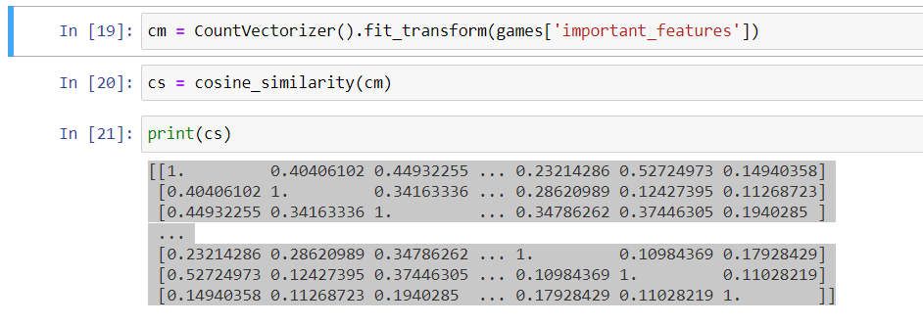
FIG.1- use of countvectorizer in model

Dropna() - CSV files occasionally include null values that are later seen as NaN in Data Frames. The user may examine and remove Rows/Columns containing Null values in various ways using Pandas dropna() function.

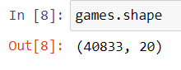

FIG.2-Before using dropna() in model

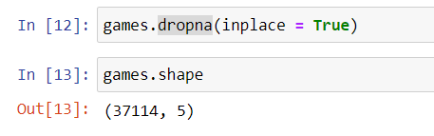

FIG.3-After using dropna () in model

As we compare data size is reduced drastically after removing rows/columns which consisted from steam_data.

Feature Selection

In my model, feature selection was a supporting but significant factor. The characteristics that I have chosen from the steam data are:

- Names
- Developer
- Popular tags
- Genre
- Game details

My programme may thus more accurately propose the games by considering these characteristics.

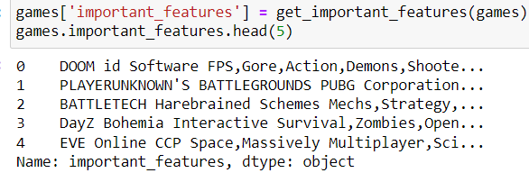

FIG.4-Feature selection in model

Chapter 5
MODEL BACKGROUND

To identify the video games that players are most likely to like playing, this model largely uses cosine similarity. Cosine similarity is a statistic that may be used to assess how similar data items are, regardless of size. Python's Cosine Resemblance function may be used to compare two texts for similarity. Cosine similarity treats each data object in a data set as a vector.

Even if a user John hasn't played a certain game, his preferences for that game may be inferred by looking at other users who have and who also like other games that John does.

Chapter 6
RESULT & FUTURE SCOPE

The efficacy and viability of the suggested system have been successfully tested. The algorithm has a 98% accuracy rate for making game recommendations. This demonstrates how cosine similarity may be applied to vector form data to identify similarities. To make this model more user-friendly and accessible in the future, the data may be updated often. Additionally, a model that can determine if a system satisfies the basic criteria for a game and alert the user can be created. This approach may also be used in a mobile gaming application.

Chapter 7
CONCLUSION

The major emphasis of this project was on constructing a powerful and robust recommendation system for steam users so that gamer’s may play games which they would undoubtedly like as this recommendation system works on count vectorizer which has offered high accuracy for this model.

References

- Robert M Bell, Yehuda Koren, Chris Volinsky. The BellKor 2008 Solution to the Netflix Prize.
AT&T Labs Research. 2008.

[2] R. Bell and Y. Koren, and C. Volinsky. “The BellKor solution to the Netflix Prize”.
http://www.netflixprize.com/assets/ProgressPrize2007_KorBell.pdf. 2007.

[3] Steffen Rendle, Christoph Freudenthaler, Zeno Gantner and Lars Schmidt-Thieme. BPR:
Bayesian Personalized Ranking from Implicit Feedback. UAI 2009

[4] Maciej Kula. Metadata Embeddings for User and Item Cold-start Recommendations. RecSys
2015

[5] Tong Zhao, Julian McAuley, Irwin King. Improving Latent Factor Models via Personalized
Feature Projection for One Class Recommendation. CIKM, 2015

[6] Ruining He, Julian McAuley. VBPR: Visual bayesian personalized ranking from implicit
feedback. AAAI, 2016

- Wang-Cheng Kang, Julian McAuley. Self-attentive sequential recommendation. ICDM, 2018

[8] Mengting Wan, Julian McAuley. Item recommendation on monotonic behavior chains.
RecSys, 2018

[9] Apurva Pathak, Kshitiz Gupta, Julian McAuley. Generating and personalizing bundle
recommendations on Steam. SIGIR, 2017

[10] Nicolas Usunier, David Buffoni, and Patrick Gallinari. Ranking with ordered weighted
pairwise classification. In Proceedings of the 26th Annual International Conference on Machine
Learning, ICML ’09, pages 1057–1064, New York, NY, USA, 2009. ACM

